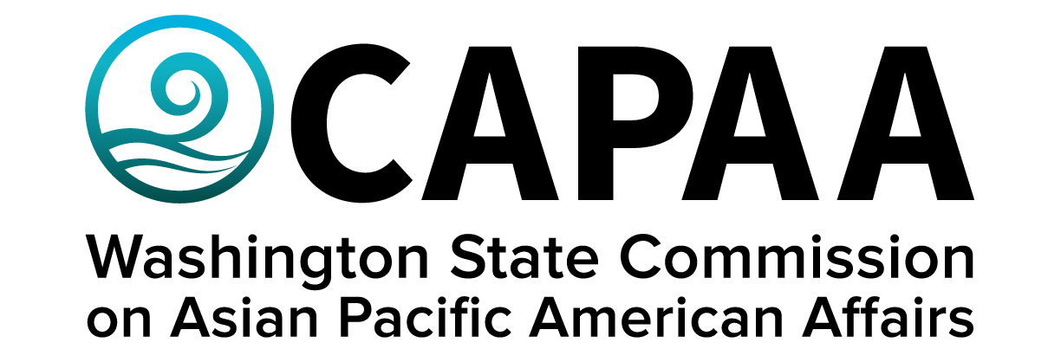

**Executive Director’s Report**

**January 18, 2020**

Prepared by Toshiko Grace Hasegawa

January Public Board Meeting

City of Tacoma, Pierce County, WA

Asia Pacific Cultural Center

4851 S. Tacoma Way, Tacoma, WA 98409

Improving the well-being of Asian Pacific Americans by examining issues, advancing advocacy, and ensuring access to government.

**Executive Director’s Report**

January 18, 2020

Executive Director’s report to the Commission covering activities, progress, and updates from November 15, 2019 to January 10, 2020.

1. **STAFF AND COMMISSION ACTIVITY**

The following is a summary of CAPAA’s Agency Activity Inventory as reported by the Office of Financial Management for appropriate period 2017-2019.

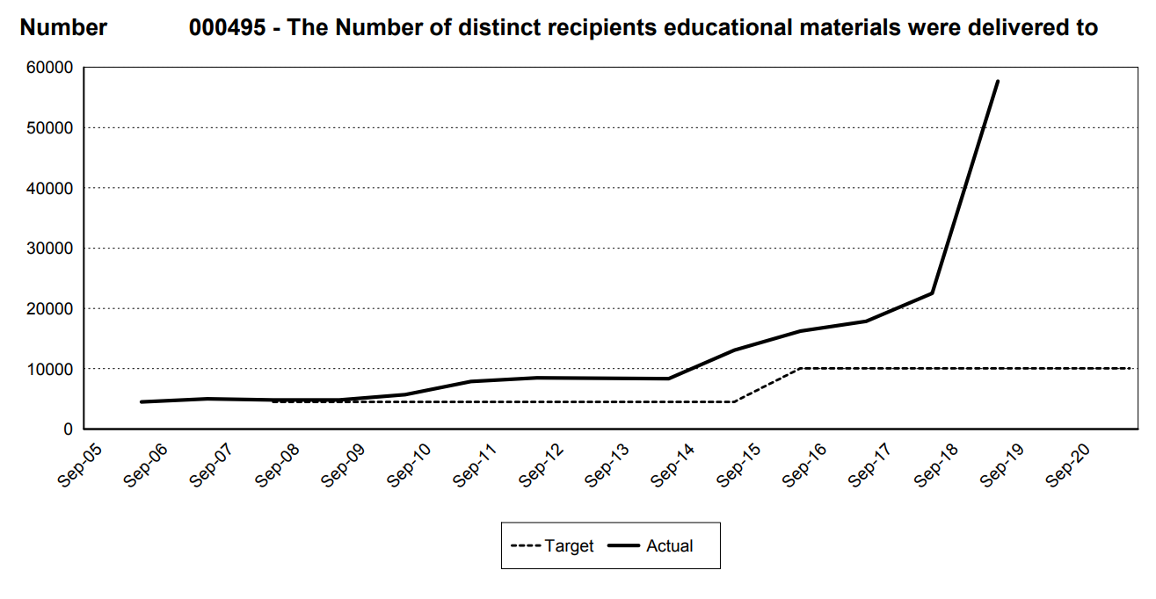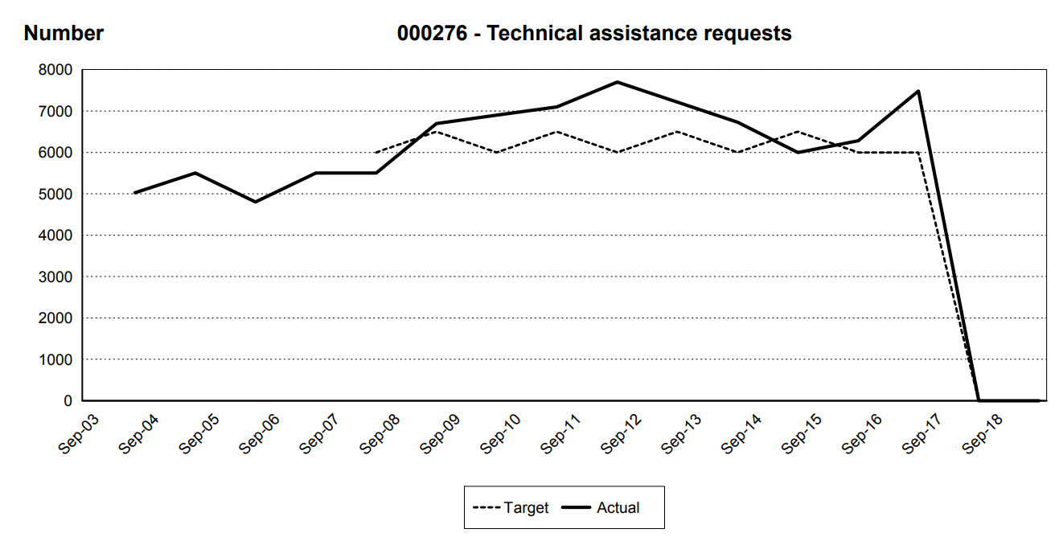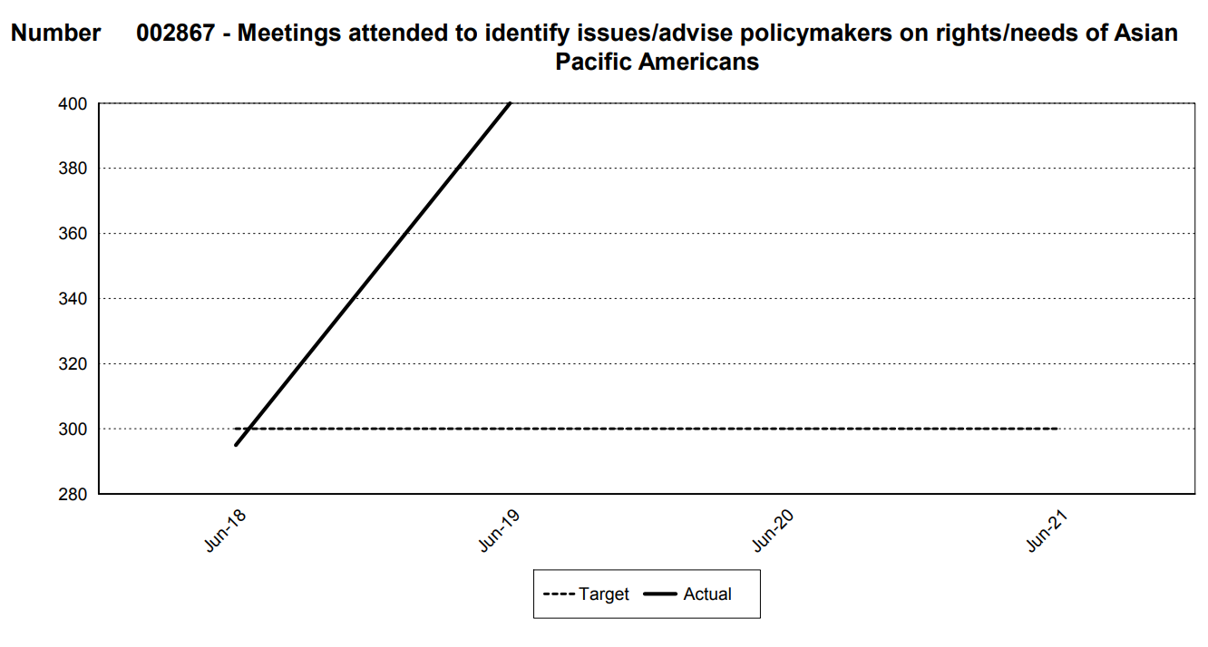

**Governor’s Leadership Academy & Ruth Woo Fellowship:** Applications opened Friday, 1/10, 2020 to serve upon the Governor’s Leadership Academy, with a special opportunity for one member of the 2020 cohort to serve as the Ruth Woo Fellow. Applications will be reviewed beginning 1/15/2020 on an ongoing basis until an adequate candidate pool as been achieved. The Ruth Woo Fellowship was shared online via CAPAA’s newsletter and Facebook, and specifically targeted towards

**Commissioner Activity:** Commissioners submitted activity reports for the time period of November 15, 2019 – January 10, 2020. Total events reported = 66; Activity Report response rate = 83% (10/12 respondents). Details of Commissioner Activity can be found in Appendix I. Outstanding reports for this reporting period: Commissioner Gurung; Commissioner Sam.

**Appointments:** Two appointments were made for this reporting period:

* Frieda Takamura (primary) & Julie Kang (alternate) were re-appointed as CAPAA’s AA representatives upon the EOGOAC.
* Sili Savusa was re-appointed as CAPAA’s PI representative upon the EOGOAC. She will soon recommend an alternative to replace Mele Aho.
* Caryn Park was re-appointed to representative CAPAA upon OSPI’s Social Emotional Learning Advisory Committee.

Applications to serve upon the Commission will open in April, 2020. Per CAPAA’s rules, 1st Vice Chair Nam Nguyen will convene a nominations committee, which will work inclusively to establish a process to review and recommend applicants for appointment.

* Chair Dickinson’s 3rd term expires 6/30/2020
* Commissioner Gurung’s 2nd term expires 6/30/2020
* Commissioner Sisavatdy’s 1st term expires 6/30/2020
* Commissioner Sam’s 1st term expires 6/30/2020

**CAPAA Appropriation in Governor’s FY20 Supplemental Budget:** CAPAA submitted a decision package for two full time employees in the FY2020 Supplemental Budget. Additional staff will allow for CAPAA to fulfill its mandate as prescribed by the Governor, state legislature, and the public we serve. For the first time in years, the Governor has appropriated funds for CAPAA to increase its staff by one FTE.

The requested amount ($192,978) accounted for salaries, benefits, one-time costs (equipment, supplies) and other recurring centralized costs for both FTE's. The decision package can be found online at: <https://abr.ofm.wa.gov/budget/decision-packages/v1/combined?budgetSession=2019-21:S1&agencyCode=087&versionCode=S20>.

The total amount appropriated for CAPAA's as approved in the Governor's Supplemental budget covers the amount of salary and benefits for one FTE. This appropriation does not cover the cost of equipment, supplies, space, or other associated centralized costs (such as IT, Payroll, and legal support) which are charged to the agency depending upon the number of FTE's we have (these are recurring costs to CAPAA). The appropriation can be found here: <https://ofm.wa.gov/budget/state-budgets/gov-inslees-proposed-2020-supplemental-budget/agency-recommendation-summaries/087>. Staff discussed the omission of these costs in the appropriation with the Governor’s budget shop, which acknowledged the omission and committed to seeing it funded. We are working collaboratively to ensure that funds allocated to CAPAA for an FTE are sufficient for this position and sustainable for the agency’s financial model.

If CAPAA’s request is preserved by the Washington State Legislature in the 2020 Legislative Session, our appropriation would be available to the agency in April, 2020. A public call for applications and subsequent interviews would take place through May, with a new hire beginning in early June.

1. **FINANCE**

CAPAA is on track to overspend its budget by $6,451.00.Notable adjustments to the budget accounting for expenses include: Funding the Ruth Woo Fellowship ($3,000) which was approved by the executive committee, legal counsel provided by the agency Assistant Attorney General regarding updates to CAPAA’s rules ($2,899) as directed by the executive committee, and charges for new CAPAA computers ordered in June FY19 that didn’t arrive or charge to CAPAA until July FY20 ($1,491.00). CAPAA has adequate funds in its donation account to cover all costs. A summary of CAPAA’s finances to date can be found in Appendix II.

1. **RULES**

CAPAA formally filed updates to its rules as approved by Commissioners. The rules is being proposed under an expedited ful-making process that will eliminate the need for the agency to hold public hearings, prepare a small business economic impact statement, or provide responsibilities to the criteria for a significant legislative rule. Anyone who objects to this expedited rule making process has until March 2nd to make a written objection addressed to Executive Director Hasegawa at 1110 Capitol Way S. Ste. 220 Olympia, WA 98501 or [capaa@capaa.wa.gov](mailto:capaa@capaa.wa.gov). A copy of amendments as filed are attached.

1. **COMMUNICATIONS**

**Newsletter:** CAPAA’s newsletter is sent to the entire e-mail listserv of 2,066 unique e-mails on a bi-monthly basis.

**Facebook:** 1,673Likes (+ 49)

1,795 Follows (+ 47)

Women’s History Month Campaign: AAPI Women in the Suffrage Movement

1. **LEGISLATION IMPLEMENTATION & ADVOCACY**

**2020 Legislative Session:** The legislative session commenced Monday, 1/13/2020. CAPAA Project Manager Rosa Mai established an electronic bill tracking system using the online platform *Trello*. Priorities will be marked in the Trello board as identified by CAPAA staff, Commissioners, APIC-WA, the Racial Equity Team, and the POC Legislative Summit. We will also track and monitor pieces of priority legislation proposed by APA state legislators, as well as other items impacting the APA community in Washington State. CAPAA staff plans to meet formally with state legislators to discuss CAPAA’s budget request. Staff will identify opportunities to publicly testify on specific bills and consult with appropriate CAPAA committee chairs for input. As a courtesy, staff provides a heads-up to the Governor’s Office when it plans to testify before committee.

**2020 APA Legislative Day:** 2020 APA Legislative Day is taking place Tuesday, February 28 ain Olympia. This year’s continent will be a smaller group of 40-50 community leaders from across Washington State to meet with Governor Inslee, State legislators, and Washington State’s first female Speaker of the House Laurie Jenkins. As usual, CAPAA took a lead role in coordinating a meeting with the Governor, and a support role in helping APIC coordinate one large meeting for APA legislators to address community.

**Vietnamese Legislative Day & Heritage Flag Resolution:** An estimated 200 members of the Vietnamese community will make their way to the state Capital as part of the first ever Vietnamese Lobby Day, which is happening concurrently with APA Legislative Day. CAPAA was contacted by representatives of the Vietnamese community to facilitate the drafting and enactment of a proclamation by the Governor formally recognizing the Heritage Flag (yellow flag with red stripes) as a flag representing the Vietnamese community in Washington State. The proclamation will be read at Vietnamese Legislative Day.

**Lunar New Year Resolution:** Representative Thai and Senator Nguyen are co-sponsoring the first ever resolution recognizing lunar new year in Washington State. The reading of the resolution will occur in the House Chambers on Wednesday, January 22nd, and will be followed by a reception on Friday, January 24th, from 12 PM – 1 PM at the Senate Rules Room. In honor of the holiday, CAPAA will provide lucky red envelopes to all legislators stuffed with business cards and small candy.

**Day of Remembrance:** The annual Day of Remembrance resolution commemorating President Roosevelts signing of Executive Order 9066 and the mass incarceration of 120,000 people of Japanese ancestry during WWII will take place Thursday, February 20th in the House Chambers (exact time TBD). The reading of the resolution will be followed by a bento lunch hosted by Senator Hasegawa and Representative Santos, which is free and open to the public to attend. RSVP is requested, though, to achieve a more accurate head count for lunch.

**CJTC Rulemaking Process on Independent Investigations:** The Criminal Justice Training Commission (CJTC) unanimously voted to approve updated rules for a, “completely independent investigation” into police use of deadly force. Members were appointed by the CJTC at the December 5th meeting to an Ad Hoc Committee to plan the first Annual Summit on Criminal Justice training practices and other issues. Letters went already out to them and they will soon be setting up planning meetings. However, no representatives of the Asian American or Pacific Islander community was appointed to the committee, nor any representative of an immigrant/refugee group. APIC is considering drafting a letter to the CJTC urging the appointment of an AA and/or PI representative.

On January 1, 2020, 25-year old Clando Anitok was shot and killed by Spokane County Sheriff’s deputy when he allegedy failed to comply with an officer. Clando Anitok is a beloved member of Washington State’s Marshallese community. CAPAA was contacted directly by the victim’s cousin when he learned of the incident. Staff subsequently alerted the 940 implementation team, APIC-Spokane co-chairs, CAPAA and Spokane County representative Lisa Dickinson of the Spokane area, and CAPAA Civil Rights Committee members. Because Spokane County Sheriff is the involved agency, Spokane Police Department and Washington State Patrol will be conducting the independent investigation, per the requirements of Initiative 940. Sheriff Ozzie Knezovich's comments on the independent investigation is at 00:03:30 mark of the following link: <https://www.krem.com/mobile/article/news/crime/man-shot-and-killed-by-spokane-co-deputy/293-41ab218f-6869-41f5-8a1e-8532c7e5ec00?jwsource=fb>

**COFA Health Care Open Enrollment:** Open enrollment into a silver level qualified health plan for coverage in 2020 for COFA Health Care closed December 30th. Over 1,200 community members were successfully enrolled, which is the largest number to date since the programs enactment.

**COFA Dental:** The Health Care Authority released an RFI to conduct outreach into the COFA community about COFA Dental. COFA leaders plan to apply. CAPAA representatives are vocal about the need for the HCA to hire COFA community members to conduct outreach into their own community.

**COFA Senate Joint Memorial:** With Senator Bob Hasegawa as the legislative sponsor and support from the Governor, community allies are drafting a Senate Joint Memorial from the WA State House and Senate to U.S. President Donald J. Trump and Congress to formally request that Congress take the appropriate steps to restore federal benefits for COFA migrants including Supplemental Nutrition Assistance Program and Medicaid; ensure that COFA citizens are appropriately counted as part of the 2020 Census; and immediately begin work on COFA renewal negotiations.

**Equity Office Task Force:** The Equity Office Task Force is on the brink of filing its preliminary report to the Governor and Washington State legislature. The Governor allocated $1,000,000 in his proposed supplemental budget to establish a Statewide Office of Equity, which would be the first of its kind in the United States. Legislation to establish an Office of Equity is being introduced by Representative Mia Gregerson and Senator Manka Dhingra. The Equity Office Task Force will continue to convene over the next six months to flesh out nuances of the role, function and structure of the Equity Office.

CAPAA sent a letter to the Equity Office co-chairs to ask the following:

* Whether the report will include dissenting opinions in the official report. The co-chairs declined.
* Whether the Chairs will make a call out for member statements. The co-chairs declined.
* Whether the Chairs will consider running the meeting by Robert’s Rules of Order to more effectively hold the meeting to time, more accurately capture votes, and capture member comments in a more structured way. The co-chairs declined. (The current model for operating the meeting is a concensus-building model, by which members show thumbs up, thumbs sideways, and thumbs down (which indicates they absolutely cannot live with the proposal.)
* To request that the report change its cover photo from one of task force members (including CAPAA E.D. Hasegawa) to one of the community. The co-chairs approved.

1. **CAPAA PROJECTS**

**Needs Assessment - Census 2020 Work Plan Report-Backs:** CAPAA and Kaya Strategik conducted their Census Community Report Backs in Whitman County on December 11, 2019, and in Clark County on December 16, 2019. The Thurston County Report Back will take place in February, 2020 to align with APIC’s Census 2020 Calendar.

**2020 APA Blood Drive:** CAPAA staff and Commissioner Tam Dinh met with Dr. Yan Wu, Chief Medical Officer at Bloodworks NW, who is leading the effort to educate communities of color on the importance of donating blood.They educated us on the paucity of blood donations in the AAPI community and [why ethnicity matters when it comes to receiving a blood transfusion](https://www.nytimes.com/2019/05/14/well/live/blood-type-race-racial.html). We learned the educational, accessibility and cultural barriers to AAPI’s donating and receiving blood. Dr. Wu is on a mission to improve donation rates and health outcomes of AAPI’s. We explored the prospect of conducting an AAPI blood drive, and stated a goal of receiving 100 new blood donations from AAPI donors in Washington State in 2020 – an attainable goal CAPAA can help them achieve. CAPAA connected Dr. Wu to community leaders working in the intersection of health and community, to share her knowledge, answer questions, and gain their perspective. CAPAA staff and Health & Human Services Committee members will intimately engaged in developments to see what might be done for AAPI’s in need of transfusions.

**Washington State COFA Snap Shot for U.S. Government Accountability Office:** The compact will be re-assessed in 2021, and CAPAA is supporting an effort to compile a snapshot of the COFA community in Washington State to inform re-negotiations. The report is due in February, 2020.

**Women’s History Month Event:** The Washington State Women’s Commission (WCW) will host an event in March at South Seattle Community College featuring the untold stories of women of color in the suffrage movement. There is a formal ask from the WCW that CAPAA help identify a speaker who is knowledgeable about the role of APA women in the suffrage movement who could participate in the event as part of a panel or as a guest lecturer.

**Support for people impacted by police use of deadly force:** CAPAA staff met with representatives of the Department of Commerce who run the Victim Advocate program to discuss the potential for a fund to support people impacted by police violence in need to emotional support, legal counsel and finances to cover funeral, medical and insurance expenses. Commerce recommends a pilot program whereby non-profits providing such support systems compete via RFP to report back to the legislature on services provided and number of people served. E.D. Hasegawa will have an exploratory conversation with Public Defenders Association which runs model program to gauge interest in such an opportunity.

1. **CAPAA EVENTS**

**Ethnic Commission Reception Welcoming POC Elected Officials Statewide**

January 27, 2020

6:00 – 8:00 PM

Hotel RL, Olympia, WA

**March Public Board Meeting –Whitman County**

Saturday, March 28, 2020

10:00 – 2:00

Washington State University, Spark Building, Rm. G45

Pullman, WA

**June Public Board Meeting – King County**

Saturday, June 27, 2020 (4th Saturday)

10:00 – 2:00

Together Center, Garibaldi Room

16225 NE 87th St. Redmond, WA

**September Public Board Meeting – Yakima County (Elections)**

Saturday, September 12, 2020 (2nd Saturday)

10:00 – 2:00

Fil-Am Yakima

211 W 2nd St. Wapato, WA 98951

**November Public Board Meeting – Snohomish County**

Saturday, November 14th, 2020 (2nd Saturday)

10:00 – 2:00

Everett Community College (Exact Room TBD)

**End of Year Celebration**

TBD

**APPENDIX I: COMMISSIONER ACTIVITY REPORTS**

