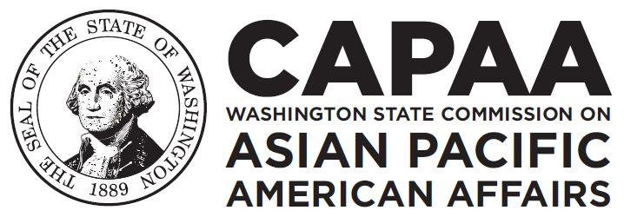
Improving the lives of Asian Pacific Americans

Public Board Meeting Agenda
Saturday, January 19, 2019 | 10:00 AM – 2:00 PM
City of Olympia, Thurston County, WA
Olympia Center, Room 101
222 Columbia St. NW, Olympia, WA 98501

Time | Agenda Item | Speaker
10:00 AM | Call to Order | Chair Tufono-Chaussee
10:00 | Welcome & Introductions | Chair Tufono-Chaussee
10:10 | Approval of Agenda  - Action to approve | Chair Tufono-Chaussee
10:13 | Approval of Minutes  - Action to approve | Chair Tufono-Chaussee
10:15 | Executive Director’s Report | E.D. Hasegawa
10:30 | Board Business  - CAPAA Meetings & Events (updated)  - Updates to WAC  CAPAA’s Travel Reimbursement Policy  - Defending Immigrants & Refugees  Rally Summary  MoU Status Updates | Chair Tufono-Chaussee  Vice Chair Dickinson  Project Coordinator Le  Commissioner Dinh  Commissioner Sam
11:00 | International Examiner & API Community Leadership Foundation (ACLF) Fellowship Program | I.E. ACLF Fellows
11:30 | Hepatitis B & C: Update | Nadine Shiroma, Advocate
12:00 | Meet the Cook: Introduction | Khurshida Begum
12:05 PM | Break | Lunch by Khurshida Begum
12:20 | Census 2020 & Complete Count | Lisa McLean, Complete Count Committee Coordinator, WA Counts 2020
1:00 | Census 2020 State Agency Work Plan Input | Chair Tufono-Chaussee
1:25 | Roundtable announcements, events & opportunities | Chair Tufono-Chaussee
1:40 | Public Forum | Chair Tufono-Chaussee
2:00 | Adjourn | Chair Tufono-Chaussee

Please Note: Times above are estimates only. The Commission reserves the right to alter the order of the agenda. For more information or questions, please contact us at (360) 725-5667. For people needing special accommodations, please provide a minimum advance notice of five business days.

Agency Overview
The CAPAA was established by the state legislature in 1974 to improve the well-being of Asian Pacific Americans (APAs) by ensuring their access to participation in the fields of government, business, education, and other areas. It has a board made up of 12-governor appointed members that represent the diverse APA communities of Washington State.

