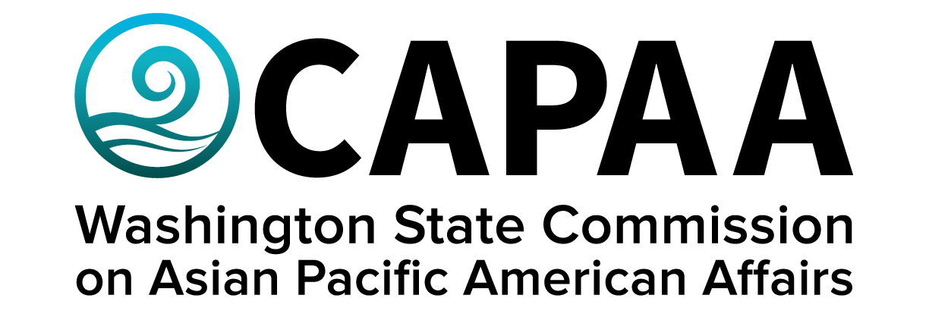

Public Board Meeting Agenda
Saturday, November 19, 10:00 am – 2:00 pm
Hirabayashi Place (442 South Main St, Seattle, WA 98104)

AGENDA
Time | Business Item | Speaker
10:00 AM | Call to Order | Chair
10:01 | Roll Call | Chair
10:02 | Welcome | Rep. Santos (37th LD)
10:12 | Approval of Agenda  - Action to approve | Chair
10:13 | Approval of Minutes  - Action to approve | Chair
10:14 | Sponsorship Requests  - United Territories of Pacific Islanders Washington  - Action to approve | Chair
10:20 | Commissioner Community Updates (5 min each) | Roundtable
11:20 | CAPAA Appointee Report-Backs | Matt Chan – Washington State Creative Economy Strategic Plan Work Group  Frieda Takamura – EOGOAC  Isa Whalen - SS-SWAC  Caryn Park - Social Emotional Learning (SEL) Advisory Committee and SEL Indicators Workgroup
11:40 | Race and Ethnicity Data – Education Research and Data Center (ERDC) in Office of Financial Management | Katie Weaver Randall, Director
12:10 | Lunch
12:30 | Grant Equity Review Update – Office of Recreation and Conversation | Megan Duffy, Director
1:00 | Public Comment
1:20 | Staff Report | Dir. Hasegawa
1:40 | Legislative Tracking preview | PM Yodkerepauprai
1:50 | Good of the Order | Chair Nguyen
2:00 PM | Adjourn | Chair Nguyen

