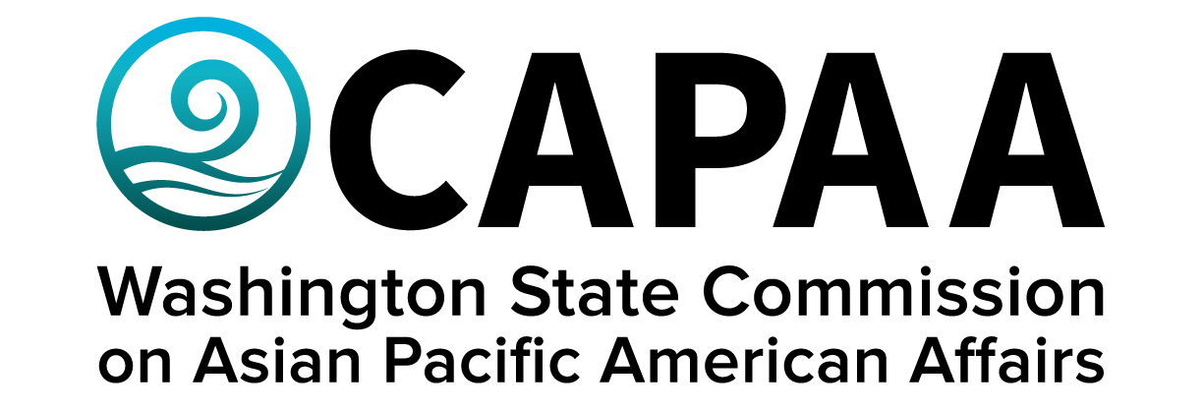

Public Board Meeting Agenda
Saturday, January 28, 10:00 am – 2:00 pm
APCC (4851 S Tacoma Way, Tacoma, WA 98409)

AGENDA
Time | Business Item | Speaker
10:00 AM | Call to Order | Chair Nguyen
10:01 | Roll Call | Chair Nguyen
10:02 | Welcome | Commissioner Emeritus  Lua Pritchard
10:12 | Approval of Agenda  - Action to approve | Chair Nguyen
10:13 | Approval of Minutes  - Action to approve | Chair Nguyen
10:15 | Sponsorship Requests  - Spokane Fil Am NW Assn re: AA&NHPIHM Celebration | Chair Nguyen
10:20 | Commissioner Community Updates (5 min each) | Roundtable
11:05 | Staff Report | Executive Director Hasegawa
11:30 | Lunch | APCC
12:00 | Public Comment
12:30 | Statewide Sexual Exploitation Relief Center for Adult Survivors (and other priorities) | Representative Orwall
12:40 | Environmental Policy Priorities – transportation sector | Kelly Hall – Climate Solutions
12:50 | SB 5304 re: Testing individuals to provide language access to state services | Maria Siguenza CHA Director
12:55 | Legislative Preview | Project Manager Yodkerepauprai
1:10 | Representative Jake Fey
1:15 | CAPAA 50th Anniversary Planning | Executive Director Hasegawa
1:50 | Good of the Order | Chair Nguyen
2:00 PM | Adjourn | Chair Nguyen

Sponsorship Request:

