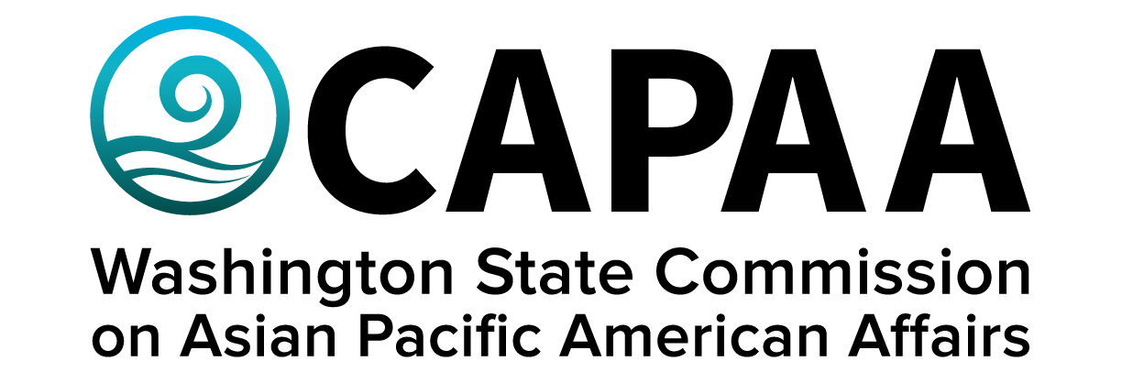

**Staff Report**

**March 11, 2023**

Prepared by:

Executive Director Toshiko Hasegawa

Project Manager K’gnausa Yodkerepauprai

Project Coordinator Brenda O’Brien

March Public Board Meeting: **Thurston County**

Improving the well-being of Asian Pacific Americans by examining issues, advancing advocacy, and ensuring access to government.

**Staff Report**

March 11, 2023

Staff report to the Commission covering activities, progress, and updates from January 28, 2023 to March 10th.

1. **STAFF AND COMMISSIONER ACTIVITY**

**Commissioner Activity:**

Commissioners submitted activity reports for the time period of January 14 to February 25, 2023.

Total events reported = 78; Activity Report response rate = 100% (12/12 respondents). Outstanding reports for this period: *none.* Details of Commissioner Activity can be found in Appendix I.

Commissioner Satpal Sidhu resigned from his post on Tuesday, 3/7, citing inability to meet the minimum requirements of the position. The Executive Committee will review the most recent pool of applicants to fill the vacancy.

Four Commissioners are up for re-appointment in 2023:

* Julio Diaz (King County)
* Ekkarath Sisavtady (King County)
* Va’eomatoka Valu (King County)
* Ping Ping (King County)

CAPAA re-appointed Frieda Takamura (alternate Brianne Ramos) & Sili Savusa (alternate Lydia Faitalia) to the EOGOAC.

1. **FINANCE**

**Financial Status Report:** The January 2023 Financial Status Report shows that CAPAA is in good financial condition. CAPAA will return to the legislature with a 2023-2024 supplemental budget request to cover the cost of a necessary website rebuild and webpage services provided by WA Tech.

**Sponsorships:** One request for sponsorship was approved:

* $500 – Khmer Community of Seattle King County – Khmer Amarak – 3/25 5:00 – 10:00

At the last public board meeting and most recent executive committee meeting, the Commission discussed the need for a cap to distributing community grants from the agency donation account. In section 3.10.40 of the agency’s Administrative Policy Manual (page 21), policies related to a maximum distribution of donation funds read as follows:

*“The Commission may only expend up to 5 percent of its donation account, calculated at the beginning of the fiscal year, for sponsorship per fiscal year. The Commission may not provide sponsorship funds for a single request that exceeds five hundred dollars ($500).”*

The current balance in our donation account is about $30,000 (so 5% would be $1,500.) That means that for this fiscal year, there has been an overspend in our donation account in violation of our agency policies in the amount of $4,000. The following is a chart of approved CAPAA sponsorships in the current fiscal year. (Note that this list excludes the most recently approved sponsorship request, for a total of $5,500.

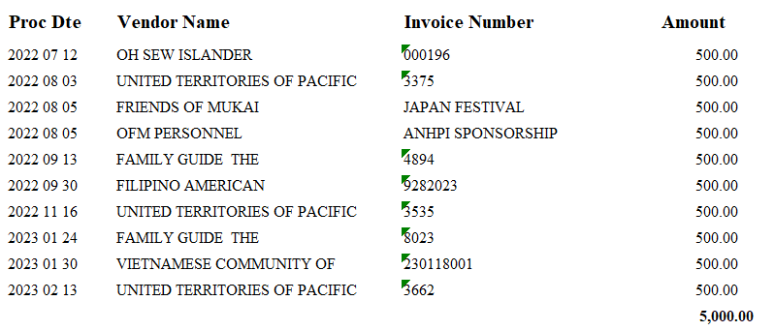

Just last year, the agency underwent an audit of all CAPAA expenses, including sponsorships, which it passed with top marks. The $4,500 overspend has been reported to OFM and will be mentioned in the next audit.

1. **EQUITY TRAINING**

In April 2018, Gov. Jay Inslee issued a memorandum — [Inclusive and Respectful Work Environments](https://gcc02.safelinks.protection.outlook.com/?url=https%3A%2F%2Fofm.wa.gov%2Fsites%2Fdefault%2Ffiles%2Fpublic%2Fshr%2FDiversity%2FSubCommit%2FGovernor_Inslee_Memo_Inclusive_and_Respectful_Work_Environments_%2528002%2529.pdf%23%3A~%3Atext%3DIdentify%2520best%2520practices%2520for%2520incorporating%2520diversity%252C%2520equity%2520and%2Caccountable%2520in%2520building%2520and%2520maintaining%2520a%2520respectful%2520workplace.&data=05%7C01%7CToshiko.Hasegawa%40capaa.wa.gov%7C3c5465f9b9f54ac04bd508db16be67e8%7C11d0e217264e400a8ba057dcc127d72d%7C0%7C0%7C638128779263307679%7CUnknown%7CTWFpbGZsb3d8eyJWIjoiMC4wLjAwMDAiLCJQIjoiV2luMzIiLCJBTiI6Ik1haWwiLCJXVCI6Mn0%3D%7C3000%7C%7C%7C&sdata=j3h3SG6BdQ%2BfmyVsIM30%2FyjJ%2BUstlwQD9rrh6gfjQeI%3D&reserved=0) — calling on agencies to take action to create inclusive and respectful workplaces.

In 2022, the governor issued [Executive Order 22-02](https://gcc02.safelinks.protection.outlook.com/?url=https%3A%2F%2Fwww.governor.wa.gov%2Fsites%2Fdefault%2Ffiles%2Fexe_order%2F22-02%2520-%2520Equity%2520in%2520State%2520Government%2520%2528tmp%2529.pdf&data=05%7C01%7CToshiko.Hasegawa%40capaa.wa.gov%7C3c5465f9b9f54ac04bd508db16be67e8%7C11d0e217264e400a8ba057dcc127d72d%7C0%7C0%7C638128779263307679%7CUnknown%7CTWFpbGZsb3d8eyJWIjoiMC4wLjAwMDAiLCJQIjoiV2luMzIiLCJBTiI6Ik1haWwiLCJXVCI6Mn0%3D%7C3000%7C%7C%7C&sdata=2K1k%2FBZjJHjk62Fr1yZ4%2FFsFQDVuI%2FsidAuzLwbMTDw%3D&reserved=0), “Achieving Equity in Washington State Government.” It calls on the State Human Resources division at the Office of Financial Management to issue a directive requiring all executive cabinet agency employees to complete diversity, equity and inclusion (DEI) training that aligns with the Office of Equity’s pro-equity anti-racist (PEAR) plan. CAPAA received confirmation that all appointed Commissioners must also take the training.

The Department of Enterprise Services is developing the training, *A Path Toward Equity: Disrupting Structural Racism through Awareness and Belonging*, as requested by State HR and based on direction established by the statewide DEI Training Committee. The purpose is to provide a foundational training for all executive branch state employees. The course aims to develop shared understanding and language around diversity, equity, and inclusion and help employees gain skills necessary for a respectful and inclusive workplace. Please see the [DES webpage](https://gcc02.safelinks.protection.outlook.com/?url=https%3A%2F%2Fdes.wa.gov%2Fdeitraining&data=05%7C01%7CToshiko.Hasegawa%40capaa.wa.gov%7C3c5465f9b9f54ac04bd508db16be67e8%7C11d0e217264e400a8ba057dcc127d72d%7C0%7C0%7C638128779263307679%7CUnknown%7CTWFpbGZsb3d8eyJWIjoiMC4wLjAwMDAiLCJQIjoiV2luMzIiLCJBTiI6Ik1haWwiLCJXVCI6Mn0%3D%7C3000%7C%7C%7C&sdata=WhaRMDOScJqT7DJIFTkDROEKIukEuv7gVIeKITYo7MQ%3D&reserved=0) for more details about the training.

The full directive is available online at the [OFM website](https://gcc02.safelinks.protection.outlook.com/?url=https%3A%2F%2Fofm.wa.gov%2Fstate-human-resources%2Fhr-directives&data=05%7C01%7CToshiko.Hasegawa%40capaa.wa.gov%7C3c5465f9b9f54ac04bd508db16be67e8%7C11d0e217264e400a8ba057dcc127d72d%7C0%7C0%7C638128779263307679%7CUnknown%7CTWFpbGZsb3d8eyJWIjoiMC4wLjAwMDAiLCJQIjoiV2luMzIiLCJBTiI6Ik1haWwiLCJXVCI6Mn0%3D%7C3000%7C%7C%7C&sdata=ZgU6CRv01%2FJtP4eeu1ySuDmN6LcLBmU5Lc7TZ93FEYA%3D&reserved=0)**. The required training includes a pre-requisite viewing of the documentary** [***Who We Are: A Chronicle of Racism in America***](https://gcc02.safelinks.protection.outlook.com/?url=https%3A%2F%2Fsowa.sumtotal.host%2Frcore%2Fc%2FpillarRedirect%3FisDeepLink%3D1%26relyingParty%3DLM%26url%3Dhttps%253A%252F%252Fsowa.sumtotal.host%252Flearning%252Fcore%252Factivitydetails%252FViewActivityDetails%253FUserMode%253D0%2526ActivityId%253D1178121%2526ClassUnderStruct%253DFalse%2526CallerUrl%253D%252Flearning%252Flearner%252FHome%252FGoToPortal%253Fkey%253D0%2526SearchCallerURL%253Dhttps%25253A%25252F%25252Fsowa.sumtotal.host%25252Fcore%25252FsearchRedirect%25253FViewType%25253DList%252526SearchText%25253Dwho%2525252520we%2525252520are%252525253A%2525252520a%2525252520chronicle%2525252520of%2525252520racism%2525252520in%2525252520america%252526startRow%25253D0%2526SearchCallerID%253D2&data=05%7C01%7CToshiko.Hasegawa%40capaa.wa.gov%7C3c5465f9b9f54ac04bd508db16be67e8%7C11d0e217264e400a8ba057dcc127d72d%7C0%7C0%7C638128779263307679%7CUnknown%7CTWFpbGZsb3d8eyJWIjoiMC4wLjAwMDAiLCJQIjoiV2luMzIiLCJBTiI6Ik1haWwiLCJXVCI6Mn0%3D%7C3000%7C%7C%7C&sdata=ov%2Bsgl3gNbVX2nMsoFLd%2FVWtANxCae4wRDq8lBkWEQM%3D&reserved=0)***,* available in the Washington State Learning Center to which you can sign up to watch. This prerequisite must be completed prior to registering for the DEI foundational training modules, expected to be available starting March 2023.**

If you have questions about the training or how to sign up to watch the pre-requisite, please contact staff.

1. **APIC LEGISLATIVE DAYS**

APIC Legislative Days took place virtually February 7 – 8 with a public kick-off event taking place February 7th @ 9:00 am, which featured a public meeting with Governor Inslee. Advocates met with several legislative offices, culminating in a meeting with Speaker Jinkins Wednesday afternoon on February 8, 2023 3:45 – 4:00 pm via Zoom.

1. **DCYF Language Access Plan**

Department of Children, Youth & Families is currently at the stage of engaging in community outreach in order to receive input into its Language Access Plan. They want to learn from organizations like CAPAA ways in which persons with limited English proficiency encounter barriers, how DCYF can best deal with these challenges, and what is currently working well.  This input will be incorporated into our Plan. They are teaming up with the University of Washington Evans School of Public Policy and Governance Consulting Lab to conduct, with community members, a stakeholder engagement effort on the language access needs of our providers and clients.  The Masters students have chosen CAPAA as a potential partner in this project hope to conduct interviews with one or two individuals from your organization who work directly with persons who are limited English proficiency. Interviews will be conducted via Zoom, during a weekday, at a time convenient for your organization, during the timeframe between late February and early March.  Interviews will be conducted by one student working with a notetaker, and will also be recorded.  The students plan to conduct one interview per person, and the interviews will be an hour or less in length.

1. **COMMUNICATIONS**

**Webpage:** Commissioner bio updates, bill tracker daily updates

**Newsletter:** CAPAA’s newsletter is sent to an e-mail listserv of 2,868 contacts (+7) from January Staff Report). The newsletter was sent a total of 3 times to the full listserv.

**Facebook:** 2,843 Follows up from2,838 in January (+5). Highest performing post was a Khmer Community of Seattle King County New Year Celebration Flyer which had a reach of 596. Posts average reach is 206 each.

**Instagram:** 150 Followers (+40). Highest performing post was Executive Director Hasegawa and Commissioner Emeritus Auntie Lua at APCC with 17 likes.

1. **UPCOMING EVENTS**

Elected Officials of Color Reception

Thursday, March 30, 5:30 – 7:00

Governor’s Mansion

June Public Board Meeting

Saturday, June 10, 10:00 – 2:00

Spokane Convention Center

334 W Spokane Falls Blvd Spokane, WA

September Public Board Meeting

Saturday, September 9, 10:00 – 2:00

Everett Community College

2000 Tower Street Everett, WA

November Public Board Meeting

Saturday, November 18, 10:00 – 2:00

Together Center, 16305 NE 87th St. Redmond, WA 98052

**APPENDIX I: Commissioner Activity Reports**

**APPENDIX II: Sponsorship: Khmer Community of Seattle King County**

