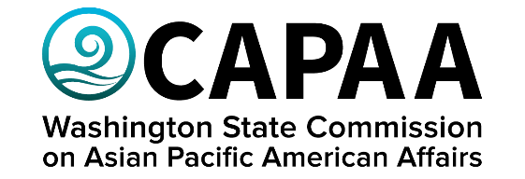

Public Board Meeting Agenda
Saturday, November 18, 2023 10:00 a.m. – 2:00 p.m.
Together Center: 16305 NE 87th Street, Suite 110, Redmond, WA

AGENDA
Time | Business Item | Speaker
10:00 AM | Call to Order | Chair Faitalia
10:01 | Roll Call | Chair Faitalia
10:02 | Welcome Remarks | State Senator Patty Kuderer  48th LD - Democrat
10:12 | Welcome Remarks | CAPAA Commissioner Lalita Uppala
10:17 | Approval of Agenda  - Action to approve | Chair Faitalia
10:18 | Approval of Minutes  - Action to approve | Chair Faitalia
10:20 | Equitable Clean Energy Transition | Troy Hutson, Director of Energy Equity  Puget Sound Energy
10:35 | Climate Solutions’ Legislative Outlook & Priorities | Leah Missik, Senior Policy Manager  Climate Solutions
10:50 | ESL Community Engagement Strategies | Carmen Rivera, Community Relations Specialist  Department of Labor & Industries
11:05 | DNR Updates | Hilary Franz, Public Lands Commissioner  Department of Natural Resources
11:20 | Staff Report | Executive Director Hasegawa
11:50 | Lunch | Mayuri
12:05 | Public Comment
12:20 | Commissioner Roundtable Updates (5 min each + 2 min Q&A) | Roundtable
1:45 | 2024 Legislative Session Look Ahead  - CAPAA priorities  - APIC priorities  - AA & NHPI Legislative Lobby Day  - Protocol for Lobbying | Project Manager Yodkerepauprai
1:55 | Good of the Order | Chair Faitalia
2:00 PM | Adjournment | Chair Faitalia

