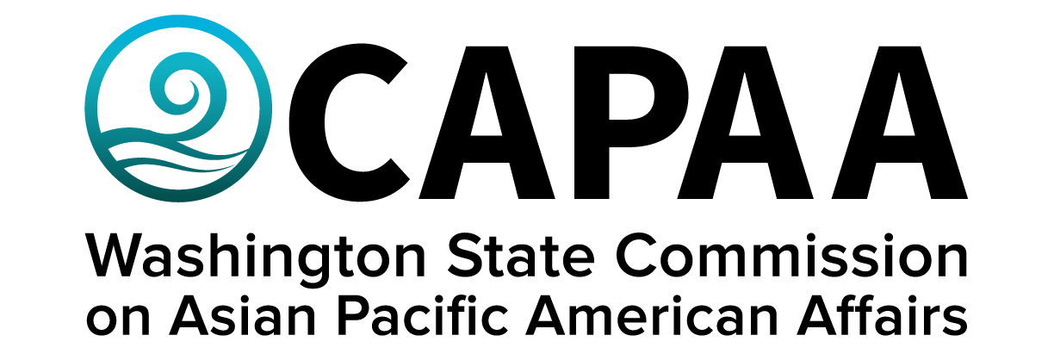

Public Board Meeting Agenda
Saturday, June 10, 10:00 am – 12:30 pm
Spokane County: VIRTUAL

AGENDA
Time | Business Item | Speaker
10:00 AM | Call to Order | Chair Nguyen
10:01 | Roll Call | Chair Nguyen
10:02 | Welcome Remarks | Rep. Riccelli
10:10 | Approval of Agenda  - Action to approve | Chair Nguyen
10:12 | Approval of Minutes  - Action to approve | Chair Nguyen
10:15 | Action Item: Administrative Policy Update  - Ch 10, pg, 60, 10.10.30 re: Commissioner travel reimbursement | ED Hasegawa
10:20 | Public Comment
10:40 | Commissioner Community Updates (5 min each) | Roundtable
11:40 | Staff Report | Executive Director Hasegawa
12:00 | AANHPI History in Public Schools | Angelie Chong  Make Us Visible – WA
12:20 | Good of the Order | Chair Nguyen
12:25 | Adjourn | Chair Nguyen

