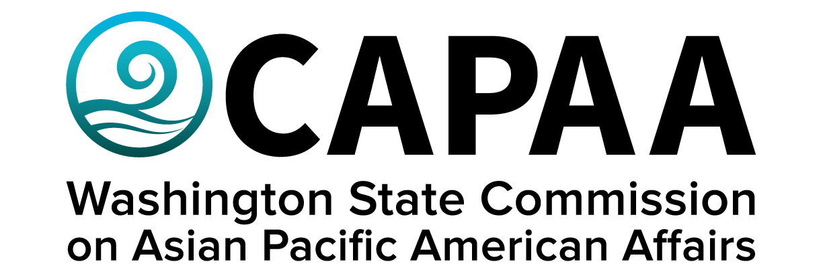

Public Board Meeting Agenda
Saturday, March 11, 10:00 am – 2:00 pm
WA State Legislative Building, Columbia Room
416 Snyder Ave SW Olympia, WA 98504

AGENDA
Time | Business Item | Speaker
10:00 AM | Call to Order | Chair Nguyen
10:01 | Roll Call | Chair Nguyen
10:02 | Welcome Remarks | Rep. Beth Doglio
10:12 | Public Comment
10:32 | Approval of Agenda  - Action to approve | Chair Nguyen
10:33 | Approval of Minutes  - Action to approve | Chair Nguyen
10:35 | Commissioner Community Updates (6 min each) | Roundtable
11:25 | Staff Report | Executive Director Hasegawa
11:45 | Lunch | Khurshida Begum
12:00 | LT. Governor’s Legislative Update | LT. Governor Denny Heck
12:15 | Legislative Update | Rep. Daria Farivar
12:25 | Governor’s Office Legislative Update | Dontae Payne,  Senior Policy Advisor
12:35 | Community Reinvestment Plan | Shaun Glaze,  HTFFSP
12:45 | Legislative Update | Rep. Sharon Tomiko Santos
1:00 | Legislative Update | Sen. Yasmin Trudeau
1:15 | Legislative Update | Sen. Bob Hasegawa
1:30 | Legislative Update  - Possible Action | Project Manager Yodkerepauprai
1:50 | Good of the Order | Chair Nguyen
2:00 PM | Adjourn | Chair Nguyen

