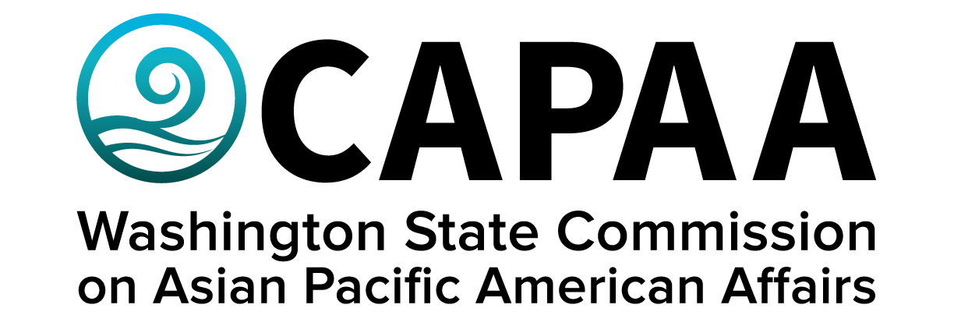

Public Board Meeting Agenda
Saturday, September 9, 2023 10:00 a.m. – 2:00 p.m.
Everett Community College, Jackson Conference Center, Room #106
2000 Tower St. Everett, WA 98201

AGENDA
Time | Business Item | Speaker
10:00 AM | Call to Order | Chair Nguyen
10:01 | Roll Call | Chair Nguyen
10:02 | Welcome Remarks | County Executive Dave Somers
10:12 | Welcome Remarks | Mukilteo Councilmember  Jason Moon
10:17 | Approval of Agenda  - Action to approve | Chair Nguyen
10:18 | Approval of Minutes  - Action to approve | Chair Nguyen
10:20 | Action item: Administrative Policy Update: Commute Trip Reduction Plan  - Action to approve | Executive Director Hasegawa
10:30 | Staff Report | Executive Director Hasegawa
10:50 | Required Equity Training - Tutorial | Project Coordinator O’Brien
11:00 | Commissioner Roundtable Updates (5 min each) | Roundtable
12:00 | Lunch | Catered by Sabaijai Thai
12:20 | Public Comment
12:35 | Elections  - Executive Committee  - Chair  - 1st VC  - 2nd VC  - Standing Committee Chairs & Assignments  - Civil Rights & Immigration  - Economic Development  - Education  - Health & Human Services  - Ad-Hoc Committee Chairs & Assignments  - 50th Planning Committee | Chair
1:15 | AA & NHPI Education Disparity Studies Update | Executive Director Hasegawa
1:35 | AA & NHPI Small Business Listening Session | Project Manager Yodkerepauprai
1:50 | Good of the Order | Chair
2:00 PM | Adjourn | Chair

