**Board Meeting Minutes**

Saturday, June 08, 2024 | 10:00 AM – 12:00 PM

Zoom Conference Call

1. **Call to Order and Roll Call**

Quorum reached at 10:01 AM. The meeting was called to order by 1st Vice Chair Uppala at 10:04 AM.

*Present:* 1st Vice Chair Lalita Uppala, 2nd Vice Chair Kendall Kosai, Cmmr. Nam Nguyen, Cmmr. Carrie Huie, Cmmr. Ping Ping, Cmmr. Ekkarath Sisavatdy, Cmmr. Sam Cho, Cmmr. Kiana McKenna, and Cmmr. David Phongsa

*Absent:* Chair Lydia Faitalia, Cmmr. Scott Lehrman, and Cmmr. Chongsun Abbott

*Staff:* Executive Director Toshiko Grace Hasegawa, Project Manager K’gnausa Yodkerepauprai, and Project Coordinator Brenda O’Brien

**II. Approval of Agenda**

Motion to approve: Cmmr. Sisavatdy

Seconded by: Cmmr. Nguyen

*No abstentions or objections. Motion carried unanimously.*

**III. Approval of Minutes**

Motion to approve: Cmmr. McKenna

Seconded by: 2nd Vice Chair Kosai

*No abstentions or objections. Motion carried unanimously.*

**IV. Sponsorship Requests**

**V. Public Comment**

**Dan Sakura** -Advisor to the Minidoka Pilgrimage Planning Committee: I’m a descendent of three generations of survivors of Minidoka. My family during WWII was forcibly incarcerated from their home in Pierce County. The Minidoka Pilgrimage Planning Committee is fighting to preserve the Minidoka national historic site in Idaho, where Japanese Americans and Alaskan natives were incarcerated from Oregon, Washington, and Alaska.

It is currently a unit of the national park system. The Biden administration just proposed a final environmental impact statement in the federal registry that would have disproportionately adverse effects to the national historic site and Japanese American community. The BLM has a 30-day period to finalize a record of decision.

We are grateful for the support of Congress, most notably Sen. Murray, to try to stop this project from happening, and we would be very grateful for the Commision’s support opposing this action and calling for a resolution of a No-Action alternative as well as protective measures to honor those who are no longer with us. There were over a 1,000 Japanese veterans who served in the military, 73 who died while serving our country, and we would like to leave a lasting educational legacy commemorating their service to current and future generations.

**Fred Thomas** – As co-chair to the Advisory Board to the Office of Independent Investigations, I am fighting for the diversity of all the people they are hiring. Of the 37 people they have hired, they have one person who identifies as Asian American and one who identifies as Pacific Islander. To me this does not show diversity and it does not show community as a whole representing our state.

At this point, I am looking for ways that they can get their job postings to your communities to ensure more representation. You can contact me to let me know where we can put these notices up. I am hoping that we can make a dent in the hiring they are doing at this time.

**VI. Kaya Strategik**

Cherry Cayabyab, Devin Abdallah, and Sachi Delacruz presented the research results of the analysis they conducted on the eligible voters in our state who identify as Native Hawiian, Pacific Islander, and Asian American. As this is a critical election year, we feel this information is very helpful in guiding the community towards voter registration, outreach efforts, and opportunities for naturalized citizenship. The eligible voter map can be accessed [**here**](https://capaa.wa.gov/population-data/2024-aa-nhpi-eligible-voter-map)**.**

**VII. Office of Equity Update**

Director Megan Matthews provided a current update from the Office of Equity. Full presentation can be accessed below.



**VIII. Commissioner Roundtable Updates:**

**Cmmr. Nguyen:** Last month the AANHPI Day was held in Lacey. It was well attended and showed how much the community is growing in Thurston County, not only amongst state workers, but also in the community. I’m looking forward to seeing its continued growth and development.

**Cmmr. McKenna:** Currently, I’m in Hawaii, attending the Festival of Pacific Arts & Culture, which takes place every four years for Islander groups. It has been on hiatus for eight years because the last one that was slated to take place was in 2020, when the pandemic started. There are 40 delegations being represented this year to celebrate and practice their arts and culture.

In Spokane, I was able to attend the closing ceremony of Heritage Month with Cmmr. Ping, an event hosted by ACL (Asians for Collective Liberation). This was an event that was strictly for joy and educational purposes of our culture and arts. It was very well attended and something that I would have dreamed about attending as a child, so I want to give a huge shoutout to ACL and Cmmr. Ping for her lovely remarks.

May has traditionally been a time where our PI communities have felt erased during Heritage Month activities, which has included use of aggregated language but no further reference to Pasifika communities during the festivities itself. I’d like to take this opportunity to ask the Commission to review the community language guidelines that we have created for ourselves, and to please adhere to that language going forward.

In other community news, we are looking forward to opening and hosting a blessing ceremony for our PICA office in Spokane at the end of July/early August. There have also been ongoing clinics for the flu and Covid vaccines.

**Cmmr. Phongsa:** Heritage Month was a busy month for me as well. I was a guest speaker at a community college here in Pasco w/ Sen. Matt Boehnke who is also an employee there. We talked about Commerce, shared their website, and conveyed the resource that is available if they need help with any digital aspects.

Cmmr. Sisavatdy and I were also able to visit Lao temples in Seattle and Kennewick to share the Lao New Year Proclamation by Gov. Inslee. I took my niece to meet up with Cmmr. Lehrman and his wife, where we were able to share the Heritage Month Proclamation to the City of Pasco.

Lastly, the Economic Development Committee will be co-hosting a small business listening forum next week for businesses in Eastern Washington.

**Cmmr. Kosai:** This year the state passed SB 5427, which established the Washington State Bias Incident Hotline. PM Yodkerepauprai and I spoke with the Attorney General’s Office regarding the institution of

this hotline. It serves as a place where people can call in to report incidents of hate and learn what resources there are as victims of bias/hate, and to be referred to services that can help.

We need to make sure our communities are aware that this is launching because it exists for them. It will also serve as a data resource in giving us important information about how hate incidents are presenting in our state. We know that incidents like this tend to be underreported in our communities and the data collected may provide insight into how to create better policies.

The program will initially roll out in three counties, which will be announced in the next couple of weeks. They are also working on funding mechanisms to be able to engage in outreach. The end goal is to have this program launched across the state in 2025.

This is a very important year as it is election year, so I want to flag how critical it is for civic engagement. Many ANHPI organizations are putting on a town hall on July 13th in Philadelphia to coincide with JACL’s and OCA’s National Conventions. They are hoping to be able to have presidential candidates address matters of importance to our communities.

Lastly, the White River Buddhist Temple will be hosting its annual Bon Odori Festival on July 27th. Everyone is welcome to attend, it’s free, and it’s a wonderful opportunity to learn about culture as well.

**Cmmr. Huie:** As it has been mentioned, May was such a busy month for celebrations and recognizing our heritage. I was asked to keynote at Plymouth Housing on May 31st and was able to share how my early childhood experiences, like the Chinese Exclusion Act, impacted my life and family. In Snohomish County, I took part in the Step Up 2024 Conference, where I was able to share about my work in behavioral health. I was pleased to hear from a nurse who had worked in the field for 40 years, comment that it never occurred to her how culture and language could play a role in mental health.

The Filipino American community in Wapato celebrated their 72nd Anniversary in April. The annual sukiyaki fundraising dinner took place a week later for the Japanese community and I was able to attend that as well. Both events were wonderful celebrations with great turnouts.

I’ve continued working with NAMI leadership on how culture comes into play in trauma. Over Memorial Day weekend, I participated in the annual placement of peonies on all the Japanese graves in Yakima County. The next day, I was able to attend the Nisei Vet Memorial event in Seattle.

Looking ahead to the Fall, the Filipino Community Hall in Yakima Valley did receive a historical landmark designation and it will be officially recognized in October. A big thank you and shoutout to Nicholas Vann who played a role in that when he was still with the Department of Archaeology & Historical Preservation.

**Cmmr. Ping:** As Cmmr. McKenna mentioned, May was Heritage Month. I was particularly moved by the Hmong author Kao Kalia Yang along with the two screenings at Garland Theater. Both Cmmr. McKenna and I were able to provide remarks at the closing ceremony and it was an event sponsored by CAPAA.

Also in May was the 50th anniversary of Expo ’74 in Spokane. While the event put Spokane on the map, the cost was also huge, as it put an end to Chinatown and the International District. The district included other minority groups such as the Japanese and Black communities.

In February, I was able to join a project researching the history of laborers from Taishan Guangdong. The Silver Letters, an exposition presented by Spokane’s United We Stand showcased the letters these laborers sent home to their families. I provided the narrative for this exhibit that took place in Chinatown, and it was a life-changing project.

Finally, I’d like to provide an update on the hate incident that occurred last spring with my college. I kept pushing the school to review and revise their policies and practices on bias toward BIPOC. Currently, as it stands it allows students to discriminate against staff and others who were not born here. Institutional plans are on its way, so I hope it can be implemented with the start of the new school year.

**Cmmr. Sisavatdy:** Asian American and Native Hawaiian Pacific Islander Heritage Month was incredible. Like many of you, I was also able to support and attend events that took place. One notably was the professional development workshop held by Make Us Visible. SE Asian history and stories in Washington State were presented. I along with former Cmmr. Tam Dinh were invited to share our experiences as refugee immigrants.

The most monumental occurrence during this last period was the Proclamation of Lao New Year that the governor signed, which was the first of its kind in our state and possibly across the country. Cmmr. Phongsa and I were able to present and share the proclamation in Seattle, Maple Valley, Woodland, and the Tri-Cities. It was blasted and shared widely by our communities not only in our state but nationally as well. I want to give a big thank you to PM Yodkerepauprai for his help with this, and to Cmmr. Phongsa for his support and deep dedication to our community.

Next year, we are coming up on 50 years of being an immigrant community, so we are thinking about what activities we would like to plan to commemorate that fact. I hope that CAPAA will be involved and helping to take the lead on some of those events.

Tomorrow is the 2nd annual Make Us Visible mixer and student exhibition from 3:00-5:00. It is open to the public, so everyone is invited to join us at APCC in Tacoma. It is really a wonderful opportunity for our incredible ANHPI students to showcase their talents.

The Lao Senior Outreach will be hosting a Sequim lavender farm outing. It will take place July 20th from 10:00-5:00 PM.

The United Committees of Laos is holding its Summer Festival on July 27th. It will take place at Lake Sammamish State Park from 11:00-7:00

The SE Asian Pacific Islander Health Education Summit is holding its annual summit at ACRS in Seattle. It will take place August 17th from 10:30-4:30 PM.

**Cmmr. Uppala:** We are collaborating with East King County APIC to host a community meet & greet with our county elected representatives. It will take place Thursday, June 13th. Our goal is to really drive community engagement with our elected officials and it will be followed up with a democracy summit in late September. We also have a very strategic “Get Out the Vote,” which will target neighborhoods with low voter turnout through door-to-door knocking efforts.

Therewill be a night market for the South Asian community in Bellevue on June 22nd. It will feature 78 small food and craft businesses/vendors.

In March alone the SE Asian community in East King County lost six high school students to mental health incidents. Because of this, we have kicked off a youth MH first aid program, which will be followed up by a safety session for parents. A new study has shown there is a strong connection between parents and adolescent MH, so the session will offer strategies for prevention and intervention.

**IX. Lunch**

The Commission broke for lunch at 11:59 AM and resumed at 12:15 PM.

**X. Governor’s International Mission to Vietnam**

PM Yodkerepauprai, Cmmr. Nguyen, and Cmmr. Phongsa presented highlights of their trip with Governor’s Office. Full presentation can be accessed below.

**XI. Golden Celebration Recap**

PM Yodkerepauprai provided highlights of the Golden Celebration that took place in March. Full presentation can be accessed below.

[CAPAA's 50th Golden Celebration](https://docs.google.com/presentation/d/1RAKrdTXDACsNs7PGOBet5YLdp4aspplU3PE3MArzD-Q/edit?usp=sharing)

**XII. Staff Report**

ED Hasegawa gave a verbal overview of the staff report. Full presentation can be viewed below.



**XIII. Operational Updates**

**ED Hasegawa:** It is with greatly mixed emotions that I share that I have formally announced my resignation from CAPAA after nearly six years. It has been an incredible experience and opportunity. This has been the best job I’ve ever had. Deep down, I don’t feel this is a goodbye. I may be stepping away from my role as Executive Director, but I know we will have numerous opportunities for us to collaborate and partner in the future. You know how to reach me, and I will always be here if you need me. The Governor’s office will be working with the chair to appoint my replacement.

That said, there is another announcement to be made. **PM Yodkerepauprai** is also leaving CAPAA. He too has turned in his resignation. He will be starting his Masters program on the East coast and hoping to take a role in local politics in New York. He has agreed to stay on until the end of August if needed, and we are working to smooth out the transition plan.

I have worked with the Executive Committee to interview for Project Manager position, and we have extended an offer to an incredible person who has accepted. There will be an overlap of two months as she works with PM Yodkerepauprai getting familiar with the position and projects we are currently undertaking.

**PC O’Brien** will be the command control as all these transitions are taking place, making sure the ball doesn’t drop through multiple transitions. Because of all the changes and added responsibility I have given her a raise recognizing the extra work she will be carrying.

**XIV. Good of the Order**

There were no announcements for the good of the order.

**XV. Adjournment**

Motion to close: Cmmr. Ping

Seconded by: Cmmr Nguyen

*No abstentions or objections. Motion carried unanimously*.

Meeting was adjourned at 1:42 PM.

**Meeting Attendees:**

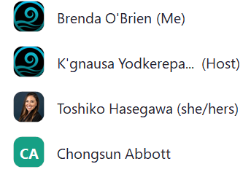

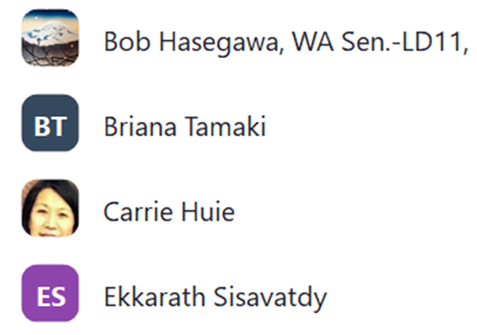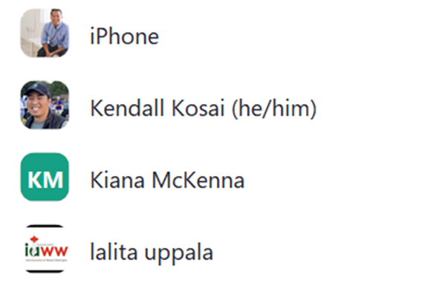

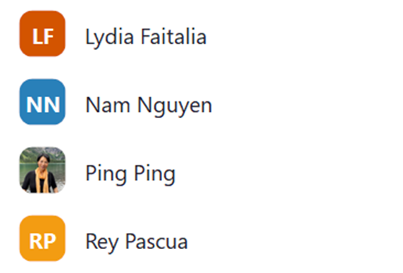

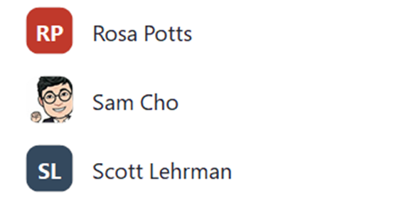

**Meeting Chat:**

**K'gnausa Yodkerepauprai** 10:05 AM  
Please message me if you if you would like to provide public comment!  
  
**K'gnausa Yodkerepauprai**  to  Everyone 10:15 AM  
Dan Sakura, Sakura Conservation Strategies, LLC, advisor to the Minidoka Pilgrimage Planning Committee, a Seattle-based non profit.  My number is 202-309-1497  dan@sakuraconservationstrategies.com

Fred Thomas ratcityfred@gmail.com  
  
**Nicholas Vann (he/him)**  to  Everyone 11:06 AM  
Hawaiians, Asians, and Pacific Islanders Promoting and Empowerment Network (HAPPEN)  
  
**Ping Ping (she/her/hers)**  to  Everyone 11:28 AM  
Thanks for your point, Nicholas: hidden by data, NHPI and Asian communities needs the visibility  
  
**Ping Ping (she/her/hers)**  to  Everyone 11:46 AM  
can't hear you Carrie  
  
**Kiana McKenna (she/her)**  to  Everyone 11:49 AM  
Every aunty and uncle has been saying hi - so sorry all for any distraction!  
  
**Kendall Kosai**  to  Everyone 12:27 PM  
How do we get the Governor to go to Japan next time?  
  
**Ping Ping (she/her/hers)**  to  Everyone 12:29 PM  
the group picture on the railroad sleeper looks so unique and historical.  
  
**Kiana McKenna**  to  Everyone 12:29 PM  
Beautiful recap - thank you all  
  
**Kiana McKenna**  to  Everyone 12:35 PM  
If you can send the link out, we will watch later for sure - thank you for all your work, staff team, on this!  
  
**DAVID PHONGSA**  to  Everyone 12:36 PM  
My wife did  
  
**K'gnausa Yodkerepauprai**  to  Everyone 12:39 PM  
https://capaa.wa.gov/commission/about-commission/golden-celebration-50-years  
  
**K'gnausa Yodkerepauprai**  to  Everyone 12:47 PM  
agreed, thank you Commissioner McKenna!  
  
**Ekkarath Sisavatdy (he/him)**  to  Everyone 12:49 PM  
Was the 50th streamed live?  
  
**K'gnausa Yodkerepauprai** 12:53 PM  
It was not.  
  
**Kiana McKenna**  to  Everyone 12:50 PM  
A very good lesson and something to think about for next time absolutely - I appreciate so much thoughtfulness around these issues

**Kiana McKenna**  to  Everyone 12:52 PM  
They food was GREAT  
  
**Kiana McKenna**  to  Everyone 12:53 PM  
The*  
  
**K'gnausa Yodkerepauprai**  to  Everyone 1:04 PM  
Small business listening session happening this coming Wednesday at 12pm focusing on Eastern and Central WA. please share to your communities!  
  
**K'gnausa Yodkerepauprai**  to  Everyone 1:04 PM  
https://us02web.zoom.us/meeting/register/tZctdOGsqjkjH9D23-Y0UGXi33BltE1W6s-H  
  
**lalita uppala**  to  Everyone 1:14 PM  
K'GNAUSA ???  
  
**Ping Ping**  to  Everyone 1:20 PM  
I am going to miss you deeply, ED.  
  
**K'gnausa Yodkerepauprai**  to  Everyone 1:20 PM  
This is the longest ive been at a job. I love CAPAA!!  
  
**Kendall Kosai**  to  Everyone 1:24 PM  
Such deep appreciation!  
  
**Kiana McKenna**  to  Everyone 1:26 PM  
I am so sorry, but have to sign off at 10:30/1:30 - would love to go next if possible so I don’t have to miss!!  
  
**Ping Ping**  to  Everyone 1:27 PM  
K'Gnausa, I echo Cmmr. Ekk's thought: think before August... You are such a beautiful impactful young manager for CAPAA.  
  
**lalita uppala**  to  Everyone 1:27 PM  
Agree Comm. Ping Ping  
  
**Kiana McKenna**  to  Everyone 1:30 PM  
Thank you all… sending love and gratitude - take care  
  
**Ping Ping**  to  Everyone 1:30 PM  
Thanks Kiana!  
  
**K'gnausa Yodkerepauprai**  to  Everyone 1:39 PM  
Thank you Commissioner Ping.  
  
**Ekkarath Sisavatdy (he/him)**  to  Everyone 1:40 PM  
Brenda, we got you! :-)

Apologies, my audio is bugging, can't hear. I'll wait to get the notes