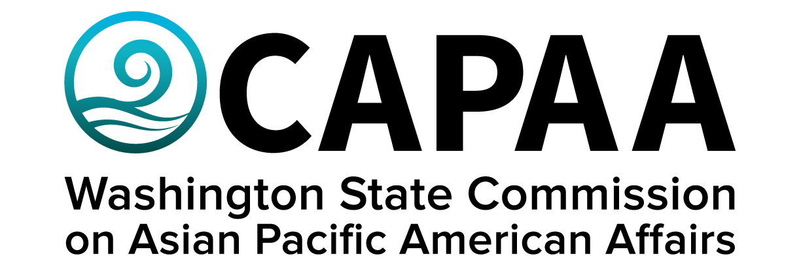

**Staff Report**

**Saturday, January 11, 2025**

Prepared by:

Interim Executive Director Nam Nguyen

Project Manager Negheen Kamkar

Project Coordinator Brenda O’Brien

January Public Board Meeting: **Online**

Improving the well-being of Asian Pacific Americans by examining issues, advancing advocacy, and ensuring access to government.

**Staff Report**

January 11, 2025

Staff report to the Commission covering activities, progress, and updates from November 16, 2024 to January 10, 2025.

**STAFF AND COMMISSIONER ACTIVITY**

**Commissioner Activity:** Commissioners submitted activity reports for the period of November 09, 2024, to January 10, 2025, for the January 11 board meeting. Activity Report response rate = 73% (8/11 respondents). Outstanding reports for this period: *3.* Details of Commissioner Activity can be found in Appendix I.

Total events reported = 51

1. **APPOINTMENTS**

The Governor’s Office has requested that the Commission reopen the appointment process for the one remaining open position. Staff have publicized the application for the position. The deadline to apply is January 31, 2025.

1. **FINANCE**

CAPAA is currently in good financial condition, spending slightly below the budget for fiscal year 2025

There were four sponsorship requests for this month. CAPAA has agreed to sponsor one of those requests, the Samoan Fashion Show on September 9, 2025 in Tacoma.

**Sponsorships Note:** Because of the limit on sponsorship-related spend, ***CAPAA will only grant applications to first-time applicants who meet all criteria.***

1. **Governor’s Budget for FY 2026-2027**

The Governor released his budget for FY 2026-27 in mid-December. The budget includes a 15% decrease to CAPAA’s operational budget, which staff had volunteered to make for FY 2026-27. The Governor’s budget, however, does include two additional allotments for FY 2026-27. The first is $100,000 for CAPAA to develop Lunar New Year programming for schools for FY 2025. The second is $75,000 for a need assessment and strategic planning for FY 2026-27.

The Governor’s budget is not the final budget. The Governor works with the Legislature on the budget, with the final version expected in May 2025.

1. **Transition to New Governor**

Governor-Elect Ferguson has begun transitioning into the governorship. He has named his executive leadership team, and the majority of the cabinet.

1. **State Legislative Session Overview**

**Overview and Purpose**

The first day of a 105-day session is January 13, 2025. Elected representatives and senators can pre-file bills which you can review [here](https://app.leg.wa.gov/billinfo/prefiled.aspx?year=2025).

The Legislature operates in biennium (2-year increments). The odd number year starts the biennium and lasts 105 days (aka "long session"); the following even number year ends the biennium and lasts 60 days (aka "short session"). The legal function of the first year is to establish a budget, and the function of the short session is to adjust or amend it - those changes are typically based on new revenue, revenue shortfall, or political pressures.

The legal duty for the State Legislature is to pass a budget for the Governor to fund its services for WA State residents. The Office of Financial Management (OFM) are the "numbers people" -- they track government spending, calculate revenue projections, and inform both the Governor and Legislature of the funding obligations to the State based on laws (*the Revised Code of Washington (RCW)*) and rules (*Washington Administrative Code (WAC)*). During legislative session, the elected representatives submit their ideas on how to provide services to constituents, and how to spend existing or new revenue.

**2025 Legislative Landscape**

We are preparing for a tighter state budget that will lead to challenging discussions over a $10 billion shortfall, and legislation proposing a state wealth tax and a new B&O tax this year.

1. **Meeting Calendar for 2025**

Online - January 11, 2025

Pierce County - March 15, 2025

Online - May 31, 2025

Spokane – September 20, 2025

King County – November 15, 2025

Staff will provide specific details on exact and location at a later date.

1. **UPCOMING EVENTS**

**Lunar New Year**

January 29, 2025

**APCC Annual New Year Celebration**

February 15, 2025 at the Tacoma Dome Exhibition Hall

**Appendix I: Commissioner Activity Report**

