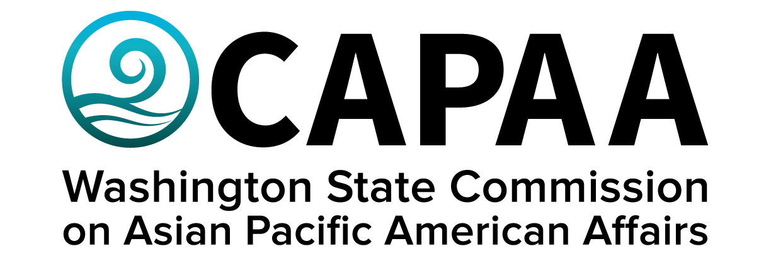

**Staff Report**

**Saturday, March 15, 2025**

Prepared by:

Interim Executive Director Nam Nguyen

Project Manager Negheen Kamkar

Project Coordinator Brenda O’Brien

March Public Board Meeting: **Asia Pacific Cultural Center**

Improving the well-being of Asian Pacific Americans by examining issues, advancing advocacy, and ensuring access to government.

**Staff Report**

March 15, 2025

Staff report to the Commission covering activities, progress, and updates from January 10, 2025 to March 11, 2025.

**STAFF AND COMMISSIONER ACTIVITY**

**Commissioner Activity:** Commissioners submitted activity reports for the period of January 10, 2025, to March 11, 2025 for the March 15th board meeting. Activity Report response rate = (11/11 respondents). Outstanding reports for this period: 0*.* Details of Commissioner Activity can be found in Appendix I.

Total events reported = 103

1. **APPOINTMENTS**

The Executive Committee interviewed three candidates for the open commission position on March 5th and made recommendations to the Governor’s Office.

1. **FINANCE**

CAPAA is currently in good financial condition, spending slightly below the budget for fiscal year 2025.

There were four sponsorship requests for this month. CAPAA has agreed to sponsor one of those requests, the Samoan Fashion Show on September 9, 2025 in Tacoma.

**Sponsorships Note:** Because of the limit on sponsorship-related spend, ***CAPAA will prioritize applications to first-time applicants who meet all criteria.***

1. **Governor’s Budget for FY 2026-2027**

Governor Ferguson released his proposed reductions, totaling $4 billion, for the 2026-2027 biennium budget. These reductions do not reduce spendings on education, law enforcement, housing, cash assistance programs such as TANF, or Medicaid. These reductions are on top of the $3 billion proposed by Governor Inslee, totaling $7 billion in budget reductions for the upcoming biennium. The total expected budget shortfall is around $15 billion. The Department of Revenue is releasing projections next Tuesday which could lower or raise the shortfall.

As part of Governor Ferguson’s budget reductions, CAPAA’s budget is lowered by 6%. In addition, all CAPAA staff (and most state employees) will have 24 furlough days in the upcoming biennium. Staff do not expect these budget reductions and furlough to change CAPAA’s upcoming plans or operation.

The Governor’s budget is not the final budget. The Governor works with the Legislature on the budget, with the final version expected in May 2025.

1. **Small Business Seminar at Kabul Seattle Community Services**

CAPAA is partnering with the Governor’s small business development team on a small business seminar/training at the Kabul Seattle Community Services, an Afghan American organization in Kent, WA, on April 14. CAPAA is working on developing the program and logistics.

1. **Educational Disparities Study Roll-Out**

The University of Washington Research Team will release the educational disparities study in May. The Educational Committee will work with the Research Team on a presentation of the results of the study to the wider community in May or June.

1. **Louder Together Webinar**

Commissioner Anna Lising is representing CAPAA on the panel discussion hosted by the Washington Women’s Commission on the importance of intersectionality in coalition building, community support, and systems change on March 26th, 6 – 7:30 pm. Sign up for the webinar at: wswc.wa.gov/upcoming-events.

1. **Meeting Calendar for 2025**

Online - May 31, 2025

Spokane – September 20, 2025

King County – November 15, 2025

Staff will provide specific details on exact locations at a later date.

**Appendix I: Commissioner Activity Report**

