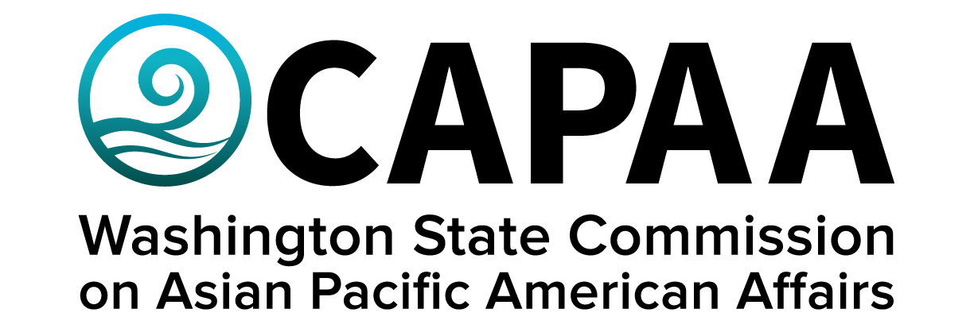

**Staff Report**

**Saturday, May 31, 2025**

Prepared by:

Interim Executive Director Nam Nguyen

Project Manager Negheen Kamkar

Project Coordinator Brenda O’Brien

May Public Board Meeting: **Virtual via** **Zoom**

Improving the well-being of Asian Pacific Americans by examining issues, advancing advocacy, and ensuring access to government.

**Staff Report**

May 31, 2025

Staff report to the Commission covering activities, progress, and updates from March 12, 2025 to May 28, 2025

**STAFF AND COMMISSIONER ACTIVITY**

**Commissioner Activity:** Commissioners submitted activity reports for the period of March 12, 2025 to May 25, 2025, for the May 31st board meeting. Activity Report response rate = 100% (11/11 respondents). Outstanding reports for this period: 0*.* Details of Commissioner Activity can be found in Appendix I.

Total events reported = 114

1. **APPOINTMENTS**

The Governor’s Office appointed Malia D’Alio to the Commission. Malia is a Native Hawaiian living in Bellingham, WA and working for Seattle Children’s Hospital as the Manager for Workforce Community and Connection. She is also co-president and tribal liaison of the Pacific Islander Health Board of Washington.

1. **FINANCE**

CAPAA is currently in good financial condition, spending below the budget for fiscal year 2025.

There were three sponsorship requests for this period. CAPAA denied two requests and approved one for Korean Culture Night.

**Sponsorships Note:** Because of the limit on sponsorship-related spend, ***CAPAA will prioritize applications to first-time applicants who meet all criteria.***

1. **Governor’s Budget for FY 2026-2027**

Governor Bob Ferguson signed the biennium 2026-2027 budget on May 20, 2025. The total budget is $77.8 billion for the biennium. CAPAA’s budget for the biennium is $1.2 million, a 33% reduction from the previous biennium. The budget does include the supplemental appropriation for Lunar New Year educational programming and a budget proviso for outreach to the COFA community on Real ID.

1. **Small Business Seminar at Kabul Seattle Community Services**

CAPAA partnered with with the Governor’s small business development team on a seminar on how to start a business at the Kabul Seattle Community Services, an Afghan American organization in Kent, WA, on April 30, 2025. The event was attended by around 25 community members. CAPAA is planning on collaborating on future events with the Governor’s small business development team and Kabul Seattle Community Services.

1. **Educational Disparities Study Roll-Out**

The University of Washington Research Team will release the educational disparities studies in June. The Educational Committee will work with the Research Team on a presentation of the results of the study to the wider community later in the year.

1. **OCA Conference**

OCA (formerly known as the Organization of Chinese Americans) is hosting their national convention in Seattle, WA from July 24 – 27, 2025. CAPAA will register any commissioner who wants to attend. Please let staff know whether you can attend by June 10th.

1. **Meeting Calendar for 2025**

Spokane – September 20, 2025

King County – November 15, 2025

Staff will provide specific details on exact locations at a later date.

**Appendix I: Commissioner Activity Report**







